Attach the Wedding Expense planner to the email & sendJ

Dear _______,

I have attached a wedding expense form that will give you an idea as far as total cost.

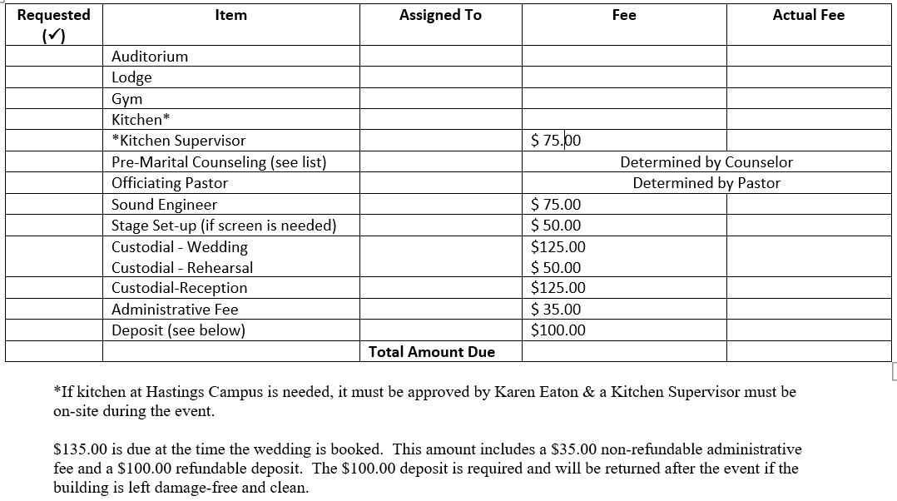

Pre-Marital Counseling will also be required if a TVC Pastor officiates & I have included below all the information on who provides that for TVC.

Pre-marital Counselors

Carla Smith

269-953-7521

[carla@tvcweb.com](mailto:carla@tvcweb.com)

3 Sessions  $75.00

Erica Schaefer

269-945-7980

[erica@tvcweb.com](mailto:erica@tvcweb.com)

3-6 Sessions

$50 per session

Eric Olsen

269-838-9927

[olsen.ew@gmail.com](mailto:olsen.ew@gmail.com)

Please email me [keaton@tvcweb.com](mailto:kforsyth@tvcweb.com) if you have any further questions.